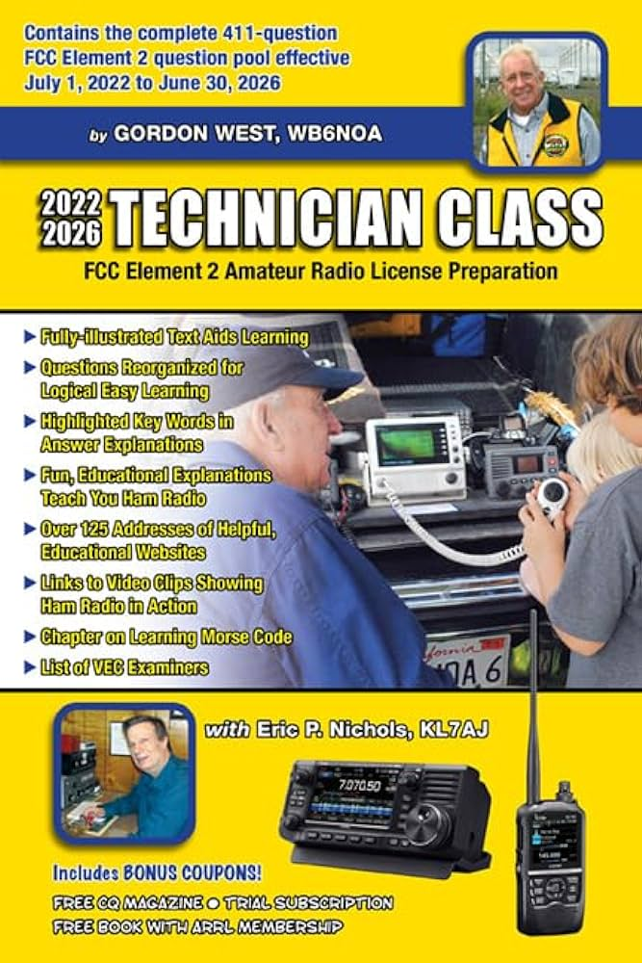
The Del Norte Amateur Radio Club will be conducting a FREE Technicians Class FCC Element 2 Radio License, the first two weeks of February. Class dates are February 3rd & 4th and 10th from 8:30 AM – 4:30 PM AND on Sunday the 11th 8:30 to noon for review and testing at 1 PM. The class will be held at the Hambro Business offices, 445 Elk Valley Road, Crescent City, CA. There will be a limited number of 24 students allowed for this class, so register on or before 21 JANUARY 2024

The course will be taught by a member of our club and President of the Pelican Bay Amateur Radio Club in Brookings OR, Lynn Hill. The above book will be provided to registered students ($30). The test fee is $15 and there is a FCC fee of $35 for the license. All fees must be paid in advance. Registration is done by visiting the DNARC website at:
W6HY.ORG
Registration requirements as stated include proper Identification AND HAVING A “FRN” NUMBER. Be sure to read the registration form carefully. Contact information is included.
From the recent fire event and subsequent temporary failure of our telephone system the need for direct communication became readily evident to several folks. The mission of amateur radio is just that, to provide emergency communications in the case of an emergency. Living in the shadow of the Cascadia Fault zone (earthquakes), and at risk of a tsunami generated anywhere in the Pacific rim area are just a couple reasons having a back up communication mechanism is just common sense. It is also a global hobby for thousands of people around the world, many of whom a HAM radio operator can talk to! Regular Club meetings are at the same location 6 PM the first Monday of each month (unless it conflicts with a federal holiday).

Jaime Yarbrough
President, Del Norte Amateur Radio Club
KJ6JKL (General Class)

